Practical 7:login form using session management

Step 1:take a one web form with name login.aspx and design ur web page as shown in below.

**Login.aspx**

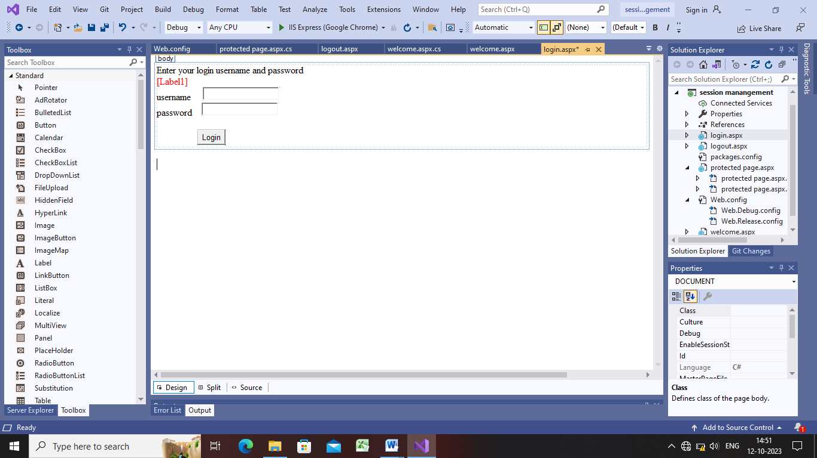

Step 2:now do the coding in login button of login.aspx form and also add web form having name welcome.aspx

**Login.aspx.cs**

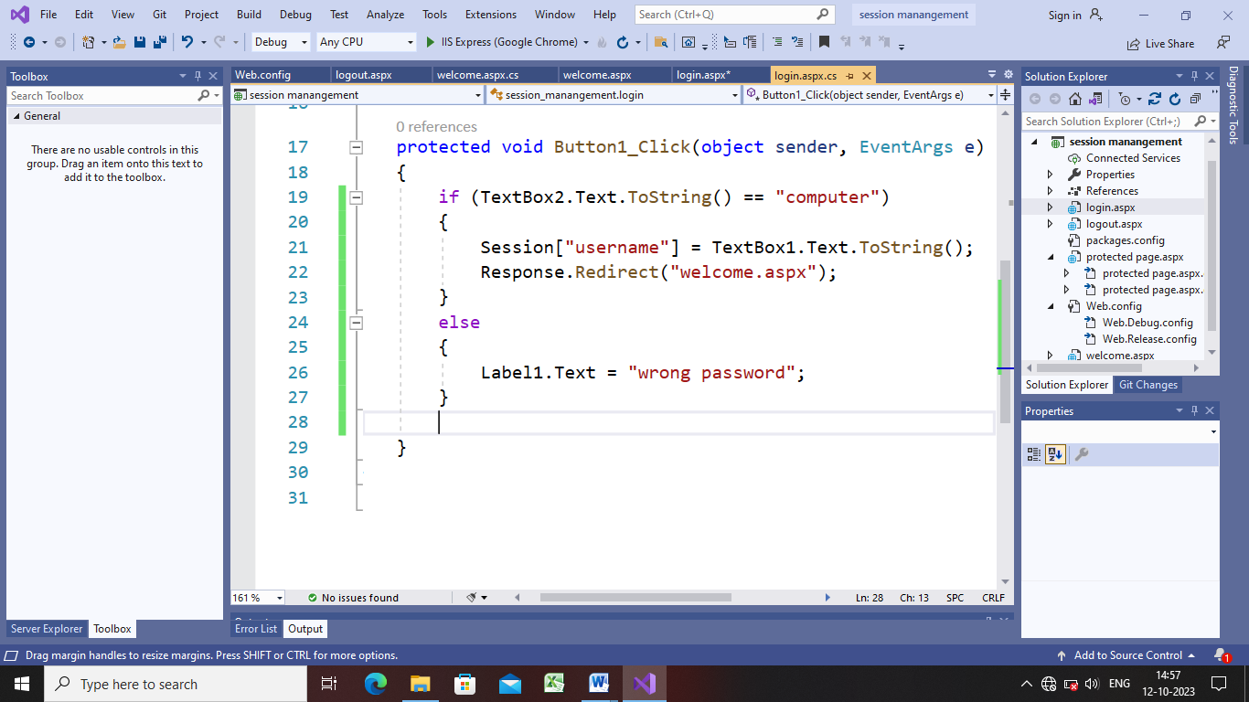

Step 3:go to welcome.aspx and design ur webpage as shown below

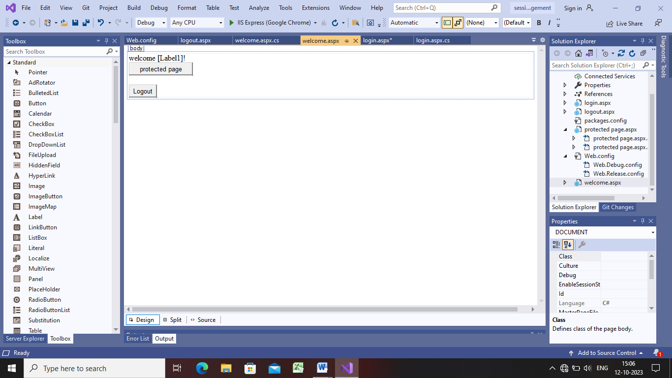

Step 4:now do the coding

protected void Page_Load(object sender, EventArgs e)

{

if(Session["username"]==null)

{

Response.Redirect("login.aspx");

}

else

{

Label1.Text = Session["username"].ToString();

}

}

protected void Button2_Click(object sender, EventArgs e)

{

Response.Redirect("protected page.aspx");

}

protected void Button1_Click(object sender, EventArgs e)

{

Response.Redirect("logout.aspx");

}

}

}

Step 5:now add 2 more web forms having name protedted page and logout page

Step 6:go to protected page

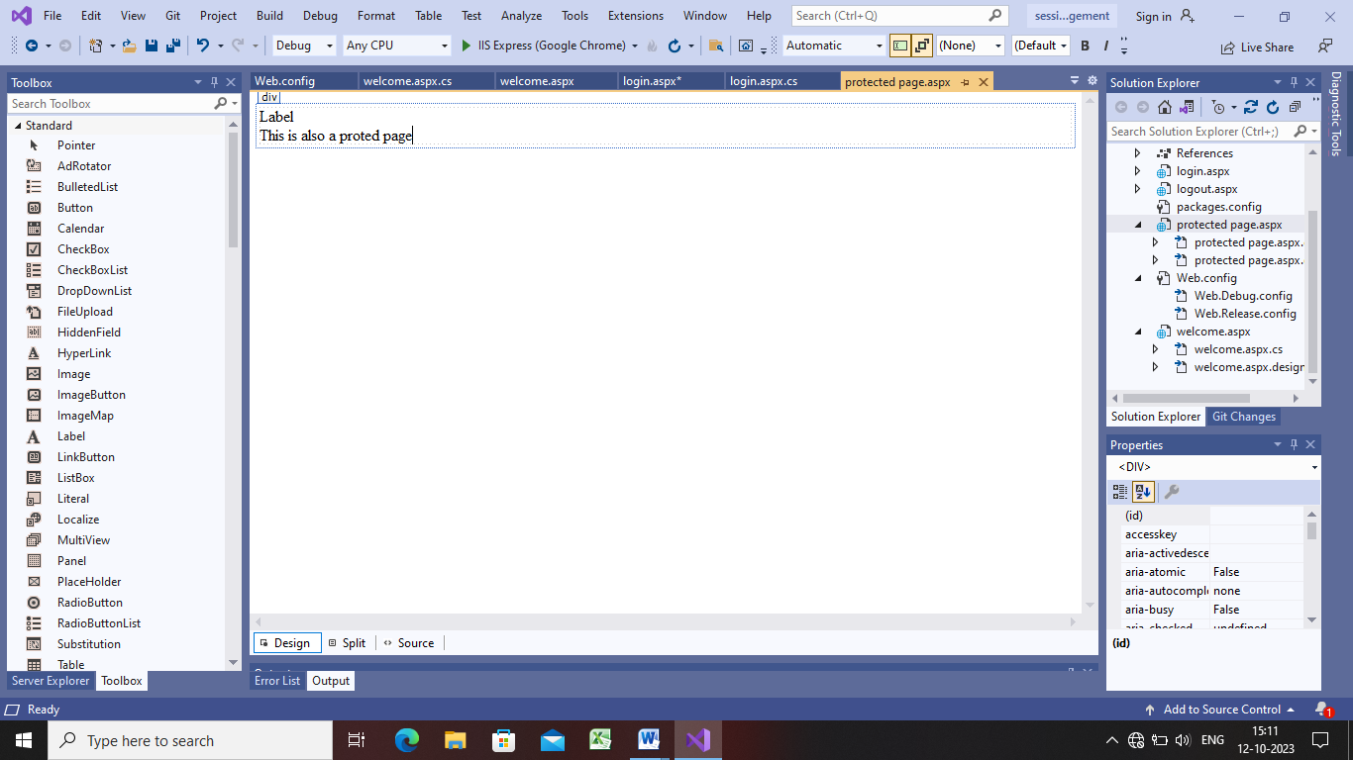

Protected page.aspx.cs:

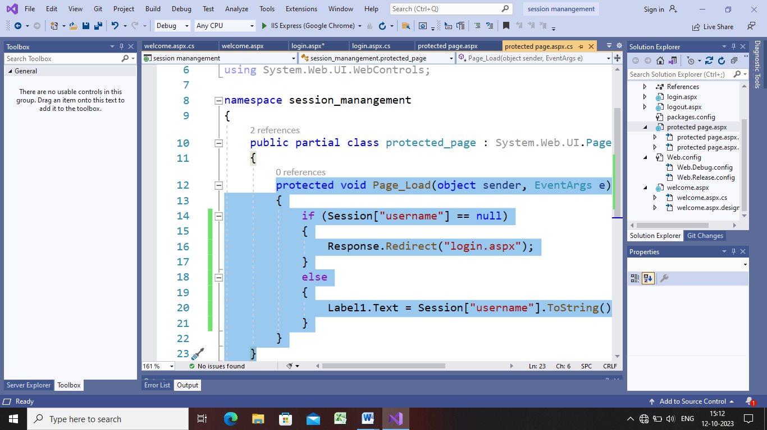

Web.config:

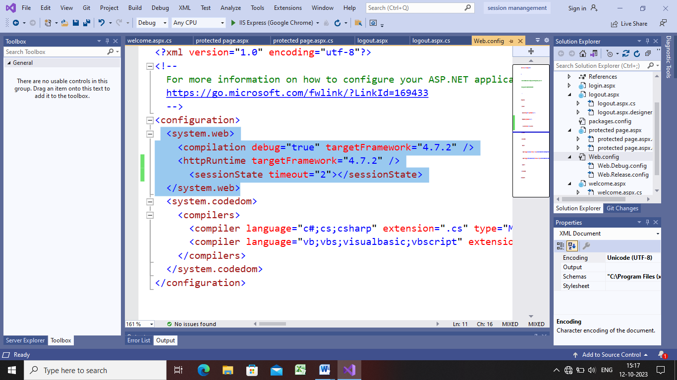

Step 7:now go to logout page and write code in logout.aspx.cs

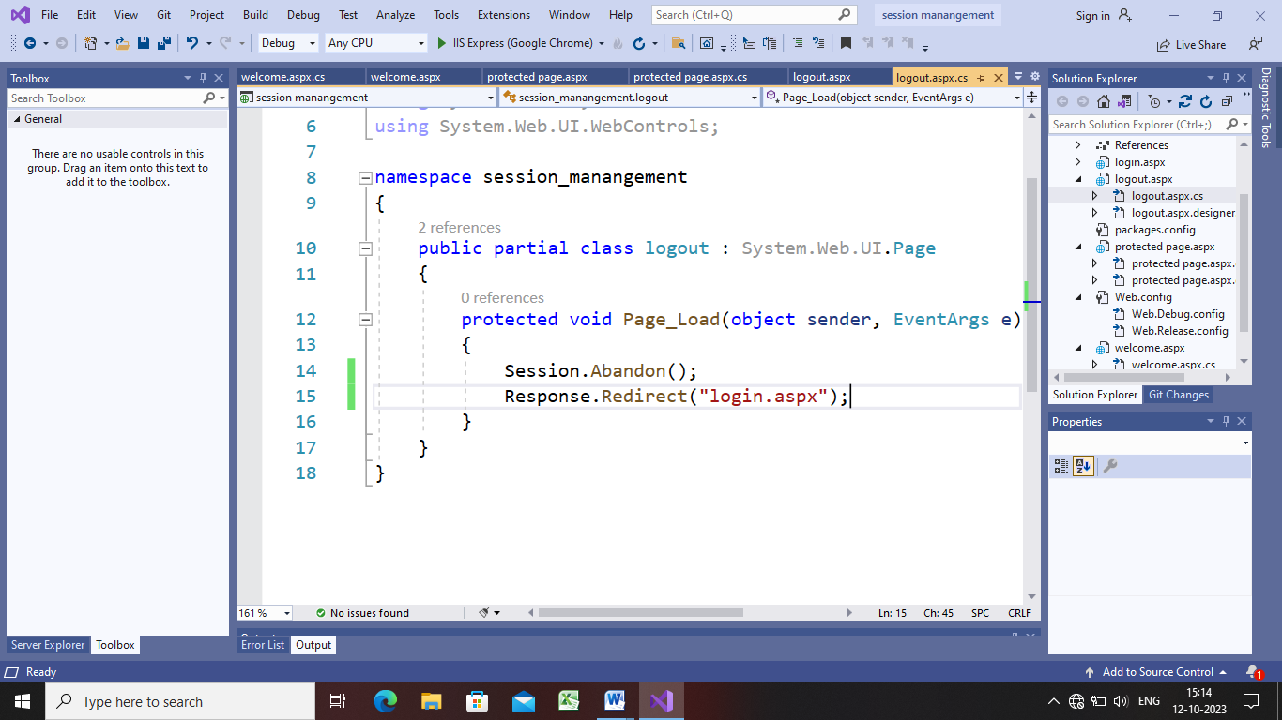

Step 8:

**Query string:-Query string is use for client side state management and state management is used to retain the value.**

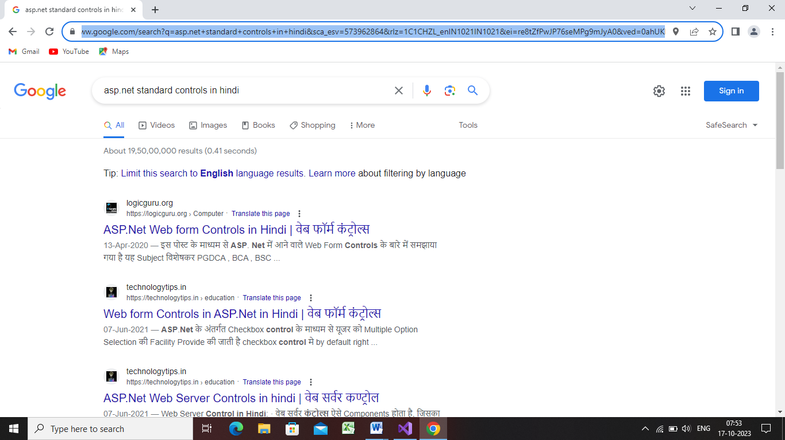

**Step 1:deign ur web page as shown below**

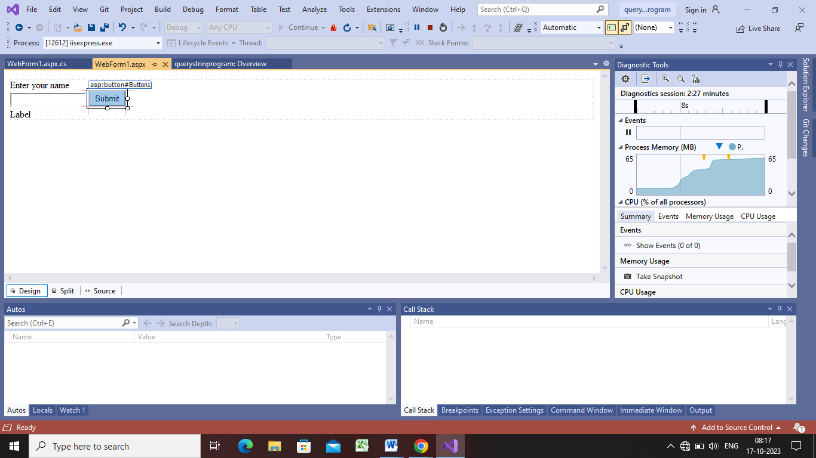

**Step2:**

protected void Button1_Click(object sender, EventArgs e)

{

Label2.Text = "welcome" + TextBox1.Text;

}



**Step 3:now delete the label2 and add new form webform2.aspx and change the coding of submit button**

**Webform1:-**

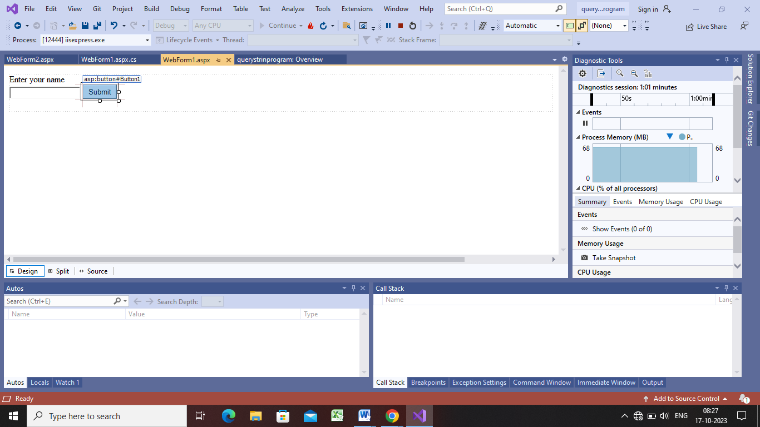

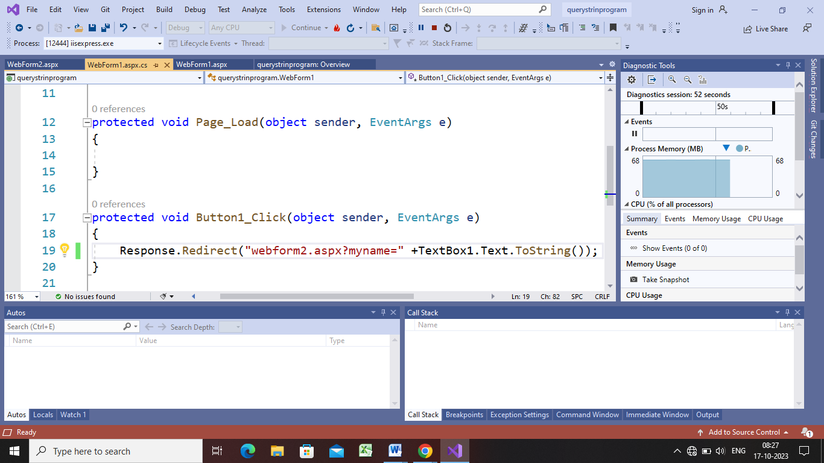





**Step5:**

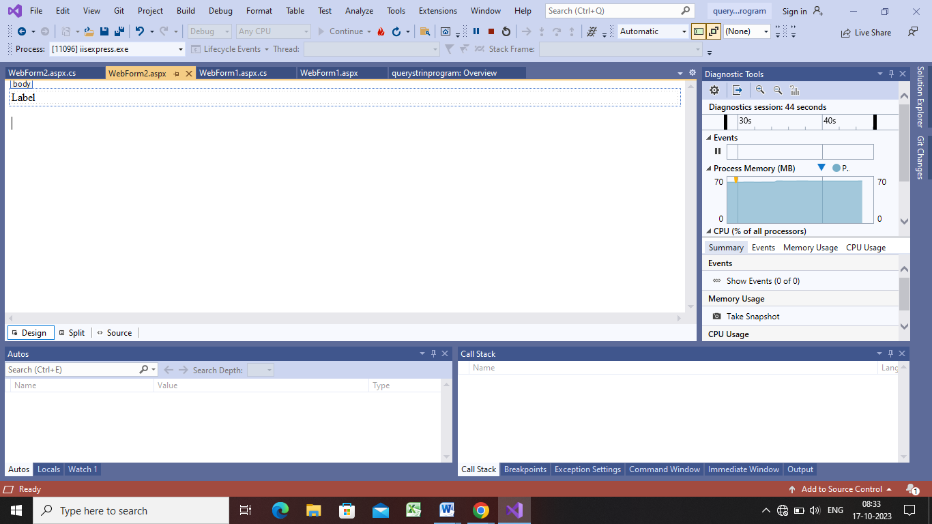

protected void Page_Load(object sender, EventArgs e)

{

Label1.Text = "welcome" + Request.QueryString["myname"];

}

**View State:**

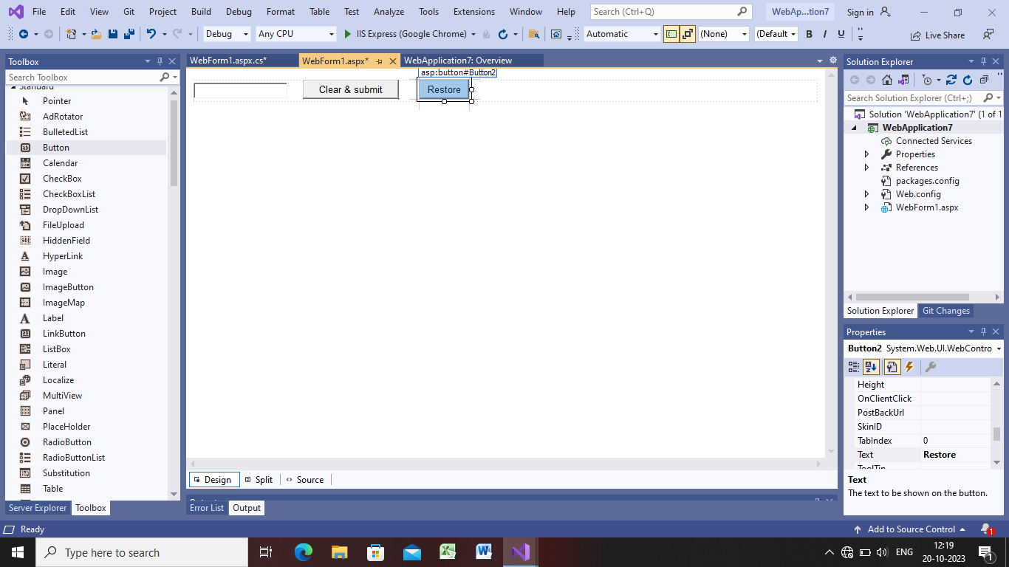**Webform1.aspx.cs:-**

using System;

using System.Collections.Generic;

using System.Linq;

using System.Web;

using System.Web.UI;

using System.Web.UI.WebControls;

namespace WebApplication7

{

public partial class WebForm1 : System.Web.UI.Page

{

string myvalue;

protected void Page_Load(object sender, EventArgs e)

{

}

protected void Button1_Click(object sender, EventArgs e)

{

myvalue = TextBox1.Text.ToString();

TextBox1.Text = string.Empty;

}

protected void Button2_Click(object sender, EventArgs e)

{

TextBox1.Text = myvalue;

}

}

}

Step next:from above code the restore button vil not work,bcz as we click on submit button the page will submit again and n form a new object or a copy of the object and we vil get new fresh page n dats why the value vil not retain by restore button and to retain the value we will use view state.in view state we save the value even if the page will load again.for future use

using System;

using System.Collections.Generic;

using System.Linq;

using System.Web;

using System.Web.UI;

using System.Web.UI.WebControls;

namespace WebApplication7

{

public partial class WebForm1 : System.Web.UI.Page

{

string myvalue;

protected void Page_Load(object sender, EventArgs e)

{

}

protected void Button1_Click(object sender, EventArgs e)

{

ViewState["myvalue"]=TextBox1.Text.ToString();

TextBox1.Text = string.Empty;

}

protected void Button2_Click(object sender, EventArgs e)

{

TextBox1.Text = ViewState["myvalue"].ToString();

}

}

}

now restore will work but as we vil refresh that page and then we will press on restore then error will display for dat we will do edit the code again

protected void Button2_Click(object sender, EventArgs e)

{

if(ViewState["myvalue"]!=null)

TextBox1.Text = ViewState["myvalue"].ToString();

}